FAQ on how Biological Diversity Act applies to the approval of Bt Brinjal (GMO) in India

What laws in our country protect our Biological resources?

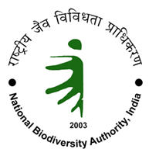
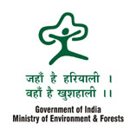
The Biological Diversity Act-2002 (BD Act) is the primary legislation for conservation, regulation of use and protection of our biological diversity and biological resources. It was enacted in conformance with the United Nations Convention on Biological Diversity-1992 (CBD) to which India is a signatory. The Environment Protection Act-1986, Wildlife Protection Act-1972, Forest Conservation Act-1980, the Protection of Plant Varieties and Farmers Rights Act-2001 and several other legislation also support the conservation and regulation of use of our biological resources. The Ministry of Environment and Forests (MoEF) is the custodian for ensuring implementation of all these laws and international conventions.

Are International Treaties binding on India to protect its biological diversity?

India is a signatory to the UN Convention on Biological Diversity -1992 (CBD), Convention on International Trade in Endangered Species of Wild Flora and Fauna -1975 (CITES) and International Treaty on Plant Genetic Resources for Food and Agriculture of the Food and Agriculture Organisation.


I

India must therefore conform with various international norms and guidelines developed under these Conventions to help conserve, protect and wisely use biological diversity. These Conventions protect sovereign rights over biological resources including the right to grant or deny access to biological resources within its territory in accordance with procedure as defined in law.

What are biological resources and how is it different from biological diversity?

Biological resources, according to the Biological Diversity Act, 2002, includes plants, animals and micro-organisms or parts thereof, their genetic material and by-products (excluding value added products) with actual or potential use or value. This definition does not include human genetic material.
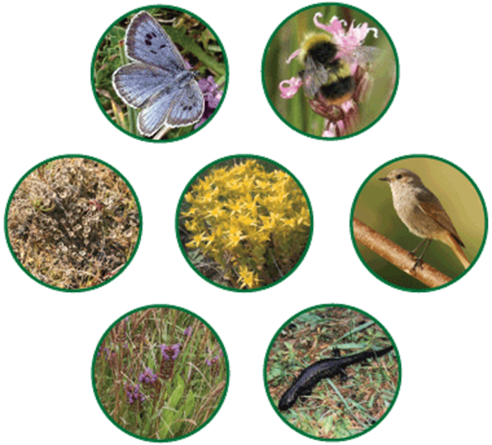

Biological diversity means the variability among living organisms from all sources and the ecological complexes of which they are part and includes diversity within species or between species and of ecosystems.

Who owns our biological resources?

All biological resources are owned by the people of India according to our Constitution. The State acts as a custodian of this natural wealth

. 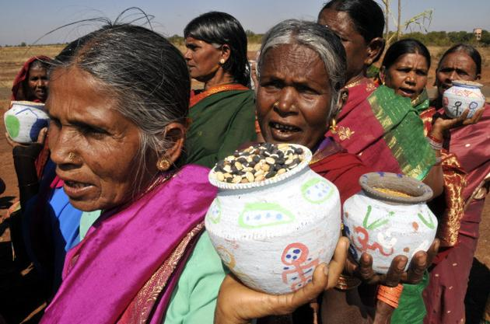

What authorities and agencies are created under the BD Act to protect and regulate the use of our biological resources?


Under the provisions of the BD Act, the National Biodiversity Authority (NBA) http://www.nbaindia.org was set up, with headquarters in Chennai, with various obligations including advising Central and State Governments on the “conservation of biodiversity, sustainable use of its components and equitable sharing of benefits arising out of the utlisation of biological resources”. An important function of the NBA is to regulate access to biological resources and ensure their fair and equitable benefit sharing. For such functions to be carried out and facilitated at the State levels, State Biodiversity Boards are also established. Members to the NBA and State Boards are appointed by Central and State Governments, respectively.

In addition, Local Biodiversity Management Committees have to be constituted at the District levels, with various powers of clearance under the Access and Benefit Sharing Protocol. In consonance with Constitutional 73rd Amendment (Panchayat Raj) Act-1992 and Constitutional 74th Amendment (Nagarpalika) Act-1992, Biodiversity Management Committees (BMCs) are established by local elected bodies, i.e., at Panchayat and Nagarpalika levels. Their primary functions involve conservation, management and regulation of biological resources, and promotion of “conservation, sustainable use and documentation of biological diversity including preservation of habitats, conservation of land races, folk varieties and cultivars, domesticated stocks and breeds of animals and microorganisms and chronicling of knowledge relating to biological diversity”.

NBA and State Biodiversity Boards must consult BMCs while “taking any decision relating to the use of biological resources and knowledge” occurring within the “territorial jurisdiction” of the BMC. In addition, BMCs may levy charges by “collecting fees from any person for accessing or collecting any biological resource for commercial purposes” within its jurisdiction. This right has been recently enhanced in the strengthening of the Access and Benefit Sharing Protocol of the CBD.

What is the protection accorded to community rights over biological resources?

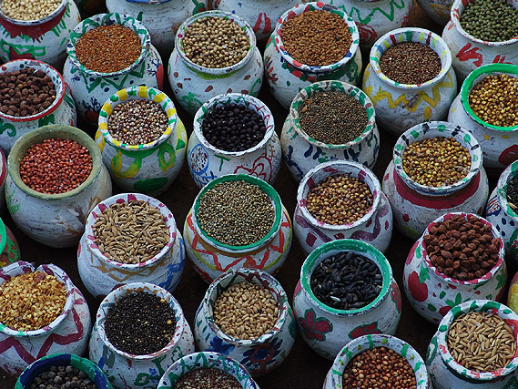
The CBD fundamentally recognizes contributions of local and indigenous communities to the conservation and wise use of biological resources, including traditional knowledge, practices and innovations. Importantly the Convention protects and provides for equitable sharing of benefits, acknowledging knowledge, practices, innovations and ownership by local communities. This is achieved by an important Protocol to the Convention known as Access to Genetic Resources and the Fair and Equitable Sharing of Benefits Arising from their Utilization.

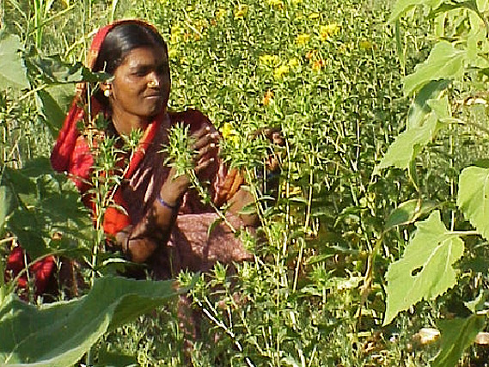
BD Act being the conforming legislation to this Convention has various provisions protecting fair and equitable sharing with the intent of protecting the interests of local communities.

Who are Benefit Claimers?

Benefit claimers are conservers of biological resources, their by-products, creators and holders of knowledge and information relating to the use of such biological resources, innovations and practices associated with such use and application.

What is Fair and Equitable Benefit Sharing?

Both CBD and BD Act promote Fair and Equitable Benefit Sharing. But neither define what it means in law.


Loosely interpreted, the benefit-sharing principle holds that countries (and communities) granting access to their genetic resources (and traditional knowledge) should receive a share of the benefits that users derive from these resources. There are serious concerns, however, over what is fair, equitable and who should be the recipient of the benefits to be shared. A large portion of the responsibility to ensure the effective implementation of this provision in the BD Act lies with the National Biodiversity Authority per Section 21 of the BD Act, and includes the following:

- NBA in consultation with the Central Government has to develop regulations and guidelines for appropriate implementation of this provision.
- Grant of intellectual property rights to the Authority, and wherever benefit-claimers have been identified, jointly to the beneficiaries.
- Ensure living standards of benefit claimers improve as a result of the use of the biological resource.
- Establish a venture capiral fund for aiding the cause of the benefit claimers payment of monetary and non-monetary compensation to benefit claimers as determined by the Authority.

The Authority is also required to ensure that where biological resource or knowledge was a result of access from specific individual or group of individuals or organisaitons, NBA should ensure that the monetary benefit arising out of the use, modification or access of the biological resource is paid directly to the individual or group of individuals or organisations.

What are the implications of CBD and BD Act to accessing biological resources for research or commercial utilization or bio-survey and bio-utilisation, including genetic modification?


Compliance with the provisions of BD Act is fundamental to accessing any biological material for any of these uses. The Act requires that prior approval of the NBA, State Boards and BMC, in consultation with each other as applicable, must be secured by the person or agency accessing biological resources. Violation of these provisions is a very serious criminal offence.

It is the responsibility of the NBA to develop necessary guidelines for the appropriate management of such access provisions. NBA developed these guidelines only in 2006.

Is there any distinction in accessing biological resources between foreigners and Indians?

According to the NBA, “all matters relating to requests by foreign individuals, companies or institutions and all matters relating to transfer of results of research to any foreigner, will be dealt with by NBA. All matters relating to access by Indians for commercial purposes will be under the purview of the concerned State Biodiversity Boards.”

Have Monsanto, Mahyco and their collaborators conformed with the Biological Diversity Act in development of Bt Brinjal?



US Agricultural Transnational Corporation Monsanto, and its subsidiary MAHYCO in India, along with their collaborators University of Agricultural Scienced (Dharwad), Tamil Nadu Agricultural University, Cornell University (USA) and a front company Sathguru Consultants, working with funding support from USAID under the Agicultural Biotechnology for Sustainability Project (ABSP II), have developed Bt Brinjal by accessing 6 local brinjal varieties from Karnataka and 3 from Tamilnadu. In so doing they have not obtained any permission whatsoever under the various provisions of the BD Act and yet, have got the product ready for commercial and environmental release pending approval of the Genetic Engineering Approval Committee (GEAC) working under the MoEF.

Similarly, there are several other companies, research institutions, and universities that are accessing local varieties of various crops and genetically modifying them for environmental release, without any conformance with the BD Act. Some of the instances involve crops of tomato, potato, ladies finger, rice, maize and many more that are in the pipeline for a clearance from the GEAC.

Ironically, MoEF is allowing one of its division (NBA) to remain silent on the violation while another division (GEAC) is actively engaged in sustaining the violation and promoting the commercial interests of the violators.

Was the issue of conformance with CBD and BD Act raised in the Public Consultations on Bt Brinjal held during 2009-10 by Mr. Jairam Ramesh, Union Minister of State for Environment and Forests (independent charge)?
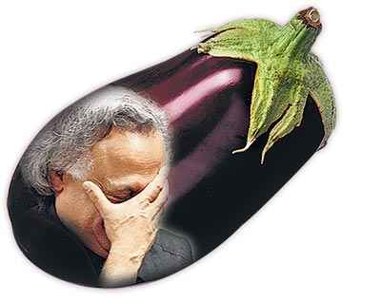
The charge that Monsanto/Mahyco and its collaborators have indeed fundamentally violated the provisions of the CBD and the BD Act was made in a detailed note submitted by Environment Support Group in the Bangalore consultation, to Mr. Jairam Ramesh. In his final report issued in February 2010, ordering moratorium on the environmental release of Bt Brinjal, he completely sidestepped the issue of violations of BD Act. Subsequently, ESG has filed copies of its complaints and other correspondence relating to violations of BD Act by Monsanto/Mahyco with the Minister, from February 2010, but has not received any formal response or direction from Mr. Ramesh.

What is ABSP?

According to USAID: Making the world hungry for GM crops, a report by GRAIN:

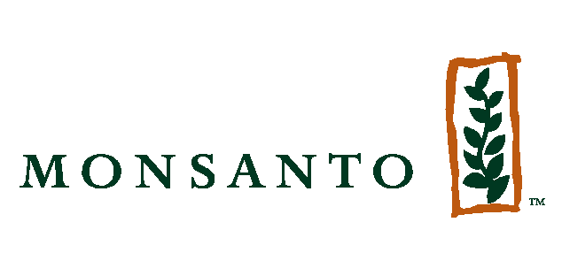
“In 1991 USAID launched the Agricultural Biotechnology for Sustainable Productivity project, later renamed as the Agricultural Biotechnology Support Project (ABSP). The Project, run by a consortium of private companies and public research institutions under the direction of Michigan State University (MSU), was mainly interested in identifying more GM crop projects from amongst the ongoing research projects at US university and corporate labs. These could then be used as entry points for US companies to collaborate with public research institutions in the South and to promote US models of biosafety and IPR (intellectual Property Rights) legislation. During the anticipated six-year project life, the project was supposed to move its targeted GM crops from the research and development stage to field-tests.”

More recently Cornell is managing the ABSP II project and its private sector partners include Asgrow, Monsanto, Pioneer Hi-Bred and DNA Plant Technology (DNAP), amongst others.

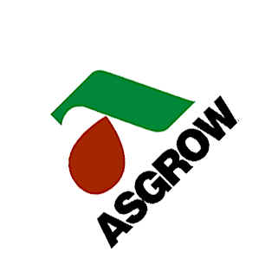
As explained by Catherine Ives, former ABSP Director, the purpose of this project is that:

"We will be working with countries to assist them in developing biosafety regulatory systems and intellectual property management systems that will promote access to, and development of, agricultural biotechnology."

Grain further reports that:

The ABSP projects were the early components of what has become a multi-pronged strategy to advance US interests with GM crops. Increasingly the US government uses multilateral and bilateral free trade agreements and high-level diplomatic pressure to push countries towards the adoption of many key bits of corporate-friendly regulations related to GM crops. But this external pressure must be complimented by internal pressure to be effective. You need people within the countries with strong connections to the levers of power making the same push and you need domestic structures that can bring the GM crops to farmers' fields and peoples' stomachs.

When did the ABSP II project commence in India and who are the partners?

The ABSP II project commenced on 4 November 2004 with the submission of a proposal to Dept. of Biotechnology, Government of India, to promote genetically modified crops capable of resisting Fruit and Shoot Borer problem.

The ABSP II project in India comprises of a consortium and they include:
- Cornell University
- Monsanto/Mahyco
- United States Agency for International Development - USAID
- Sathguru Consultants
- The Indian Institute of Vegetables Research (IIVR),
- Tamil Nadu Agricultural University (TNAU) and the
- University of Agricultural Sciences (UAS, Dharwad).

Has the NBA considered the implications and/or the violations of CBD and BD Act with respect to ongoing GMO research in India?

A review of the minutes of the National Biodiversity Authority meetings held since it was consituted reveals that no systematic assessment has ever been made of the implications of research institutions and biotechnology companies access local varieties, and of the violations that have taken place. The minutes of the meetings are on the website of the Authority: www.nbaindia.org.
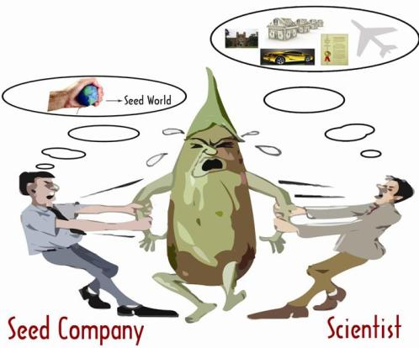
It is only when Environment Support Group lodged an official complaint with Karnataka Biodiversity Board and the NBA, alleging that Monsanto/Mahyco and its collaborators who have participated in the Bt Brinjal development have violated the CBD and BD Act, that the NBA even took notice of the issue. Even so, despite four reminders from the State Board to NBA seeking the latter's opinion on how to proceed, NBA has not offered any opinion, as yet.

Environment Support Group
[Environmental, Social Justice and Governance Initiatives]
1572, 36th Cross, Ring Road
Banashankari II Stage
Bangalore 560070. INDIA
Tel: 91-80-26713559 – 61
Email: esg@esgindia.org or bhargavi@esgindia.org
Web: www.esgindia.org

For a discussion of the problematic legal and social implications of this provision, refer to an article on “What is Fair and Equitable Benefit-sharing?” by Bram De Jonge, in Journal of Agricultural Environmental Ethics, 11 April 2010.
This report's original link is at: http://www.grain.org/briefings/?id=191. This link is inactive, but the report is accessible now at: http://www.gmwatch.org/latest-listing/1-news-items/1474-making-the-world-hungry-for-gm-crops-2542005?format=pdf Also review reports at these links: http://www.lobbywatch.org/profile1.asp?PrId=274&page=A and http://www.powerbase.info/index.php/Agricultural_Biotechnology_Support_Program

