WORKSHOP REPORT ON
ACCESS TO SAFE WATER: CHALLENGES AND OPPORTUNITIES IN MAVALLIPURA
Organised by
Environment Support Group in collaboration with the Karnataka State Council for Science and Technology and in association with Dalit Sangarsh Samithi (S)

Date: 14.3.2013 FRLHT Seminar hall, Mavallipura

Workshop on Access to Safe Water: Challenges & Opportunities in Mavallipura was organised in FRLHT (Foundation for Revitalization of Local Health Traditions) Seminar hall near Mavallipura Village north of Bangalore on 14th March 2013 from 10.00 am to 1.00 pm. The workshop was organised by Environment Support Group in collaboration with the Karnataka State Council for Science and Technology, and with local support from Dalit Sangarsh Samithi (S).
The workshop was organised on the International Day of Action for Rivers and Against Dams. Every year, thousands of people around the world lift their voices to celebrate the world's rivers and those who struggle to protect them. This is a day to celebrate victories such as tackling the impacts of dam and promoting river restoration. It is a day to take to the streets, demonstrate and demand improvements in the policies and practices of decision makers to protect and conserve rivers and water. It is a day to educate one another about the threats facing our rivers, and learn about better water and energy solutions. Above all, it is a day to unite – by acting together; we demonstrate that these issues are not merely local, but global in scope.
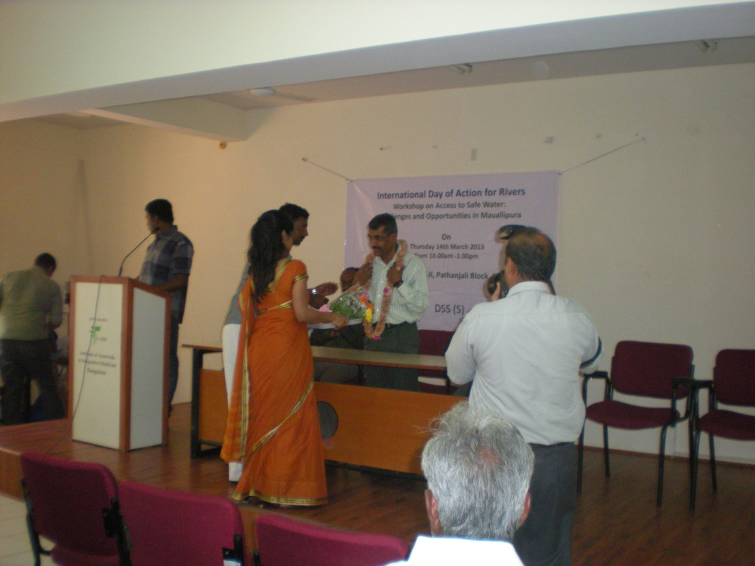
Figure 1: KSCST Secretary Mr. Shivakumar spoke on rain water conservation. He is being felicitated here.
Mavallipura, lying in the catchment area of the Arkavathy River and the Tippugondanahalli zone 1, has in the last decade experienced severe pollution of water from the Municipal solid waste landfills that have been in operation since early 2000. The unsegregated waste that has reached Mavallipura from the city of Bangalore has been dumped in two landfills over the last decade without treating the waste or the effluents that have leached from the mountains of waste lying in the region. A rough estimate of more than 40 lakh tonnes of mixed waste are rotting on the once prime agricultural land contaminating the water, soil, and air.
This workshop was organised with to raise awareness among the affected communities on the kinds of possible pollutants in the water, soil and air and the impacts on human and animal health over a period of time, the legal provisions to safe guard the area from further pollution and how community participation can help in addressing the challenges and bringing practical solutions to access clean drinking water for all.
The workshop started with a welcome address by Srinivas, leader of DSS (S), Mavallipura. He extended a very warm welcome to the Panchayat members from Mavallipura, the affected community members from Mavallipura and other affected nearby villages, and all other participants some of who were from Bangalore, Mandya and representatives from the media. The executive engineer from Mandya was also among the participants. A total number of nearly 80 people participated in the workshop.
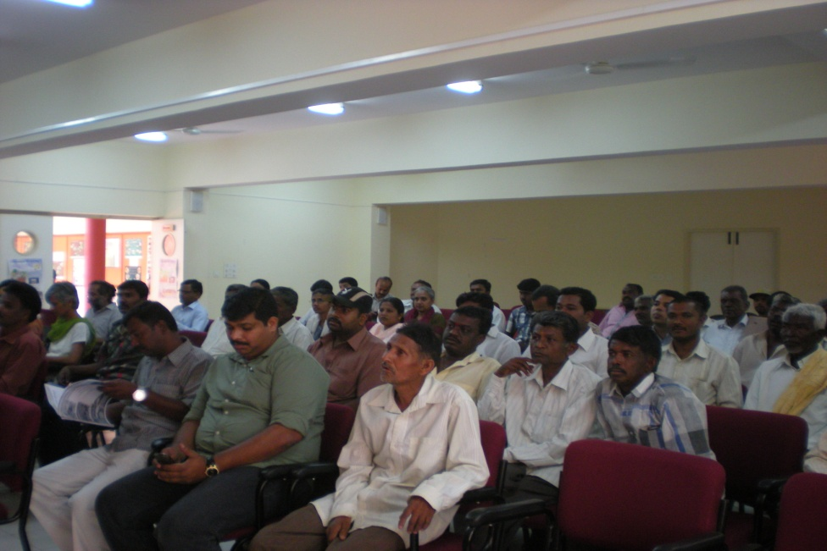
Figure 2: Participants at the workshop
Ms. Bhargavi Rao, Trustee and Co-ordinator (Education), Environment Support Group gave a wonderful presentation on the existing health and water related problems caused due to pollution from the landfills in Mavallipura. She explained how the untreated leachates are poisoning the water in the village and also ground water aquifers, and the disastrous health consequences due to spread of infectious and chronic illnesses. She concluded by saying that water is everybody’s right and no one should live without their basic right for safe drinking water.
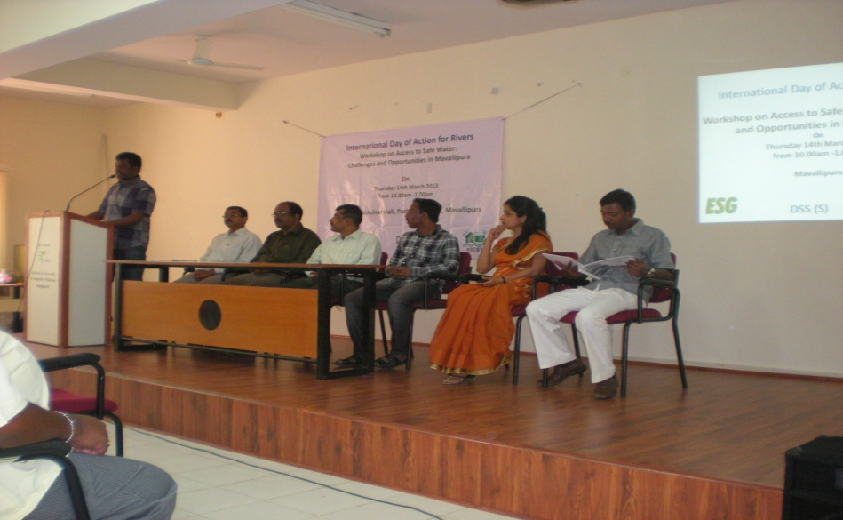
Figure 3: The Panel
Mr. Srinivas, Dalit Sangharsh Samiti (S), gave the audience an insight about how the landfills got to be located in Mavallipura, and of the villagers fight for justice against this illegal and disastrous project of BBMP. He explained how with the support from Environment Support Group and many other like minded people, they have been successful in shutting down, not one, but two, landfills. He thanked everyone who supported the villagers in their struggle for survival and in asserting their Right to a safe and hygienic environment. He also updated the audience of the on-going Public Interest Litigation filed by ESG and DSS in the High Court of Karnataka.
Mr. Shivkumar, from the Karnataka State council for Science and Technology gave a wonderfully informative and illustrated presentation on Rain Water Harvesting. He showed participants how rain water can be harvested using simple technology with cost efficient materials and how homes in Mavallipura could become water secure as a result. The participants loved the fact that an alternate source of water is possible for them based on rain water harvesting. Mr. Shivakumar gave the participants a visual example of the rain water harvesting systems installed in villages, schools and other places. He concluded by assuring that Karnataka State Council for Scientific Technology is ready to help the interested people in constructing rain water harvesting structure in their homes and community.

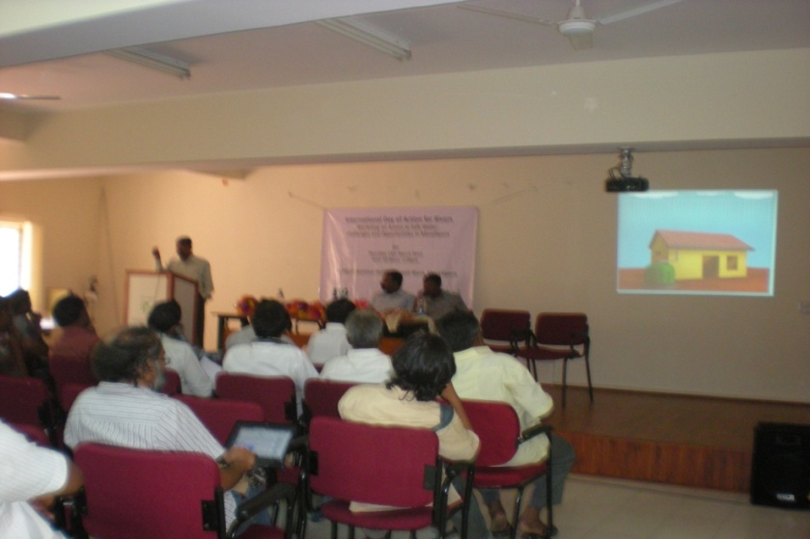
Figure 4: Mr. Shivakumar, KSCST, discussing the advantages of rain water harvesting in Mavallipura.
The next session involved a presentation by Dr. Adithya Pradyumna from Community Health Centre in Bangalore. He shared simple tips how in such highly polluted environments, some measures could be identified to secure hygiene and proper sanitation, and thus prevent diseases occurring from polluted water. He briefed them about various diseases and their prevention.
This was followed by an interactive session where the villagers interacted with the panelists.
Mr. Mallesh and Ms.Shashikala from Environment Support Group demonstrated the use of a small water testing kit for basic parameters such as pH, Hardness, Calcium, Magnesium, Iron, etc. and at the household level. Few samples from the highly polluted Mavallipura lake and drinking water (ground water) were tested for the above mentioned parameters, which revealed that the lake water should not be used even for washing purpose. A water testing kit was given to Mr. Srinivas to help people test the water quality in their wells and Bore wells and to help raise awareness.
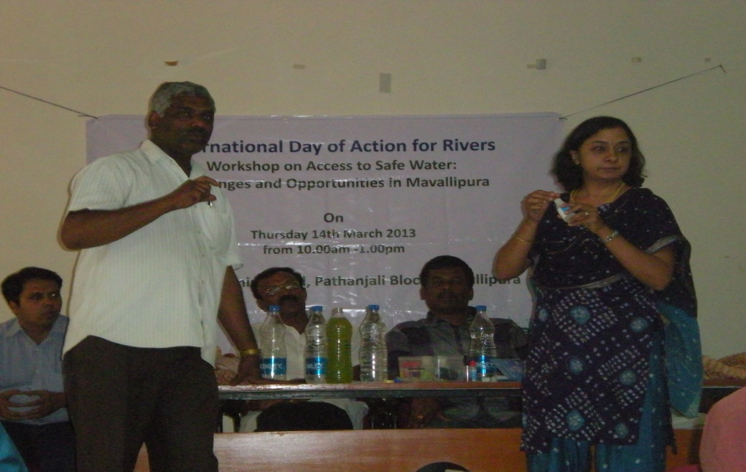
Figure 5: Mr. K. R. Mallesh and Ms. Shashikala Iyer of Environment Support Group demonstrating the use of the water testing kit.
Vote of thanks was proposed by Ms. Bhargavi and the event concluded with a great meal organised by Mr. Srinivas and his team.
Report by:
ShashikalaIyer
Programme Officer
Environment Support Group

